Application Number | 07/2019/8975/FUL
Address | Jayne Miller Ltd  7 Hope Terrace  Lostock Hall  Preston  Lancashire  PR5 5RU
Applicant | Mr Raymond McLaughlin
Agent | Mr Geoffrey Lee  Lee and Co Solicitors  Hough Lane  Leyland  Preston  PR25 2SB
Development | Change of use from (Class A1) Retail to (Class A4) Drinking Establishment with external alterations
Officer Recommendation  Officer Name | Approval with Conditions  Mrs Janice Crook
Date application valid | 15.11.2019
Target Determination Date | 10.01.2020
Extension of Time
Location Plan

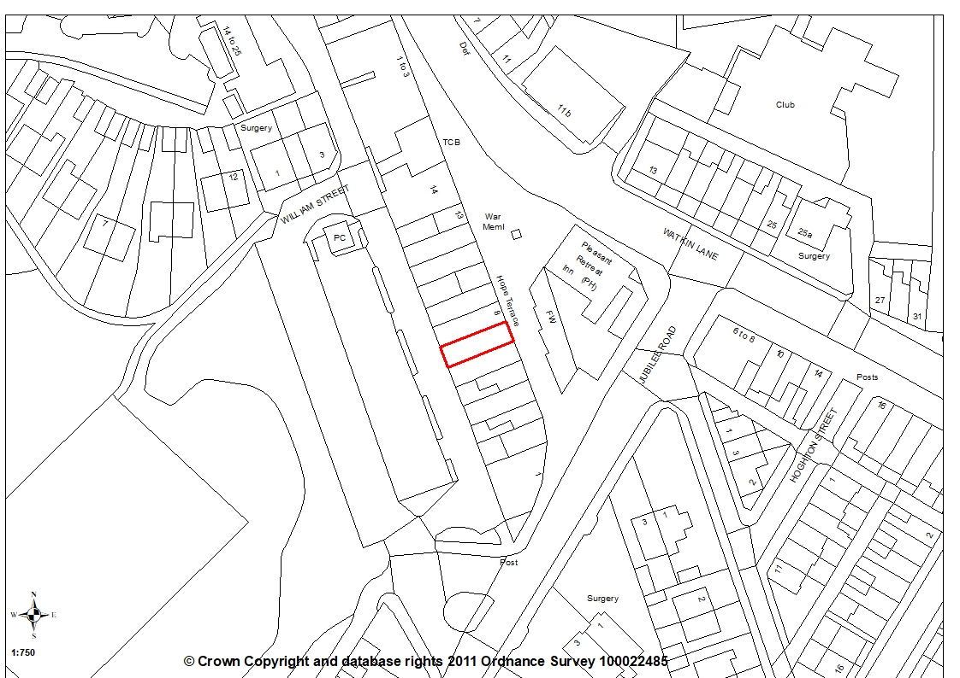
- Report Summary

1.1 The application site is within the Lostock Hall District Centre and the application proposes a change of use from a retail premises to a drinking establishment. Whilst it is accepted that the proposed change of use reduces the number of retail establishments in the District Centre, Policy E4 does allow for such changes and, on balance, it is considered the proposal will not harm the vitality and viability of the district centre and brings a vacant unit back into use.

1.2 In terms of residential amenity, any impact in terms of noise and disturbance to neighbouring residential properties can be mitigated and a condition is proposed to ensure the development is carried out fully in accordance with the Noise Impact Assessment. Although the Noise Impact Assessment has not demonstrated that there will be no impacts on the residential flat that is part of the application property, with the use of a suitable condition to restrict its use, the proposal would not unduly impact on residential amenity. The application is therefore recommended for approval.

- Site and Surrounding Area

2.1 The application relates to a retail premises at 7 Hope Terrace in Lostock Hall formerly a card shop. The site is within a terrace of commercial properties within the Lostock Hall District Centre. There is a public car park to the rear, a pedestrianised area to the front and opposite is the Pleasant Retreat public house.

- Planning History

07/1990/0472 First Floor Rear Extension. APPROVED 01/08/1990
07/2019/7688/FUL Blocking up of ground floor rear window, installation of new rear door and internal alterations. WITHDRAWN 16/09/2019

- Proposal

4.1 The application proposes the change of use of a Class A1 retails premises to a Class A4 drinking establishment together with external alterations. To the rear a window is to be removed and replaced with a new fire exit door. An existing sign is also to be removed.

4.2 To the front elevation a new window will replace the existing with a new illuminated fascia sign. This will need to be subject of a separate advertisement consent application. The existing sign above the first-floor window is to be removed. The existing boxed roller shutter is to remain.

- Summary of Publicity

5.1 Neighbouring properties were notified and a site notice posted with no letters of representation being received.

- Summary of Consultations

6.1 County Highways comment based on all the information provided by the applicant to date and after undertaking a site visit. They have no objections to the application and are of the opinion that the nature and scale of the proposals should have a negligible impact on highway safety and capacity within the immediate vicinity of the site.

6.2 They also comment that the site is within a sustainable location with good access to public transport and with a large population within easy walking distance. There is also a public car park to the rear of the site and sufficient waiting restrictions in the vicinity to control on road parking.

6.3 Environmental Health consider that the development has the potential to adversely affect nearby uses. They comment that, following a review of the acoustic report submitted as part of the application, they object to the granting of the planning permission. Following further clarification and discussion between the EHO and the applicant’s Noise Consultant, Environmental Health further commented that the applicant has failed to demonstrate that there would not be an unacceptable impact upon the residential amenity of the first floor flat from noise from either the ground floor use or adjacent cellar. Therefore, the upstairs flat should not be used for residential accommodation.

- Policy Background

7.1 Policy E4: District Centres seeks to protect and enhance the district centres to maintain their vitality and viability. Planning permission will be granted for new buildings, redevelopment of existing sites, extensions to, or change of use of existing buildings for A1 Retail Use, which will be encouraged to achieve a minimum of 60% of the overall units and A3 Cafe and Restaurant uses. Applications for other district centre uses including A2 Financial and Professional Services, A4 Drinking Establishments and B1 Offices will be permitted where this would not harm the sustainability of the shopping area.

7.2 Policy G17: Design Criteria for New Development permits new development, including extensions and free-standing structures, provided that, the proposal does not have a detrimental impact on the existing building, neighbouring buildings or on the street scene by virtue of its design, height, scale, orientation, plot density, massing, proximity, use of materials. Furthermore, the development should not cause harm to neighbouring property by leading to undue overlooking, overshadowing or have an overbearing effect; the development would not prejudice highway safety, pedestrian safety, the free flow of traffic, and would not reduce the number of on-site parking spaces to below the standards stated in Policy F1.

- Material Considerations

8.1 Impact on District Centre
8.1.1 The proposal is for the change of use of the existing retail premises, formerly a card shop, to an A4 drinking establishment. As the site is within the Lostock Hall District Centre, Policy E4 is applicable. This policy seeks to protect and enhance the district centres to maintain their vitality and viability. The policy specifies that planning permission will be granted for, among other things, the change of use of for A1 Retail Use, which will be encouraged to achieve a minimum of 60% of the overall units. However, it also allows for change of use to A4 Drinking Establishments where this would not harm the vitality of the shopping area.

8.1.2 Lostock Hall District Centre currently has 50% retail premises (as at October 2019). This has dropped since October 2018 by 9% due to currently vacant premises, including the application premises.

8.1.3 It is considered that the proposed change of use will not harm the sustainability of the shopping area, particularly given the current retail climate. It is considered preferable to have a property in use rather than remaining vacant and recognising that Policy E4 does allow for such changes of use.

8.2 Impact of External Alterations
8.2.1 In terms of the external alterations, the proposal is to remove a window to the rear and replace with a fire exit door. The existing entrance door to the first-floor flat is to remain. The existing advertisement signage is also to be removed. To the front elevation a new window is to be installed with the existing boxed roller shutter to remain. An existing sign above the first-floor window is to be removed and a new illuminated fascia sign is to be installed. This will need separate permission under the Advertisement Regulations.

8.2.2 The proposed alterations are considered acceptable and in keeping with the District Centre in which the property is located.

8.3 Impact on Residential Amenity
8.3.1 Some of the properties along Hope Terrace have first floor residential accommodation, for example 8a Hope Terrace, the adjacent property, and therefore there is the potential for the proposal to impact on the residential amenity of occupants of those apartments. The first floor of the application property is also a residential apartment with the main accommodation in the rear of the building. The proposal is to retain this apartment and store rooms and cellar to serve the drinking establishment, towards the front. The apartment is the owner’s residential flat and is use in association with the main use of the premises. The proposed floor plans indicate that the flat is vacant and it is understood is tied to the premises as a whole and cannot be sub-let.

8.3.2 The proposed change of use to a drinking establishment has the potential to create noise and disturbance to neighbouring residents. This is discussed further below.

8.4 Noise
8.4.1 A Noise Impact Assessment has been submitted to support the application. This Assessment advises the bar does not intend to play live amplified or un-amplified music or recorded amplified music and therefore has made no assessment of music noise or its impact.

8.4.2 The Assessment also advises that noise from the cellar space at first floor from fixed plant or from changing over consumables is not expected to impact on the amenity of the residential neighbour in the adjacent property.

8.4.3 In terms of customer noise transferring into the adjacent properties, this is not expected to be significant.

8.4.4 Based on predicted sound levels against the existing ambient sound levels of the area, the noise assessment concludes that sound from customers breaking out from the bar is likely to be inaudible against the existing ambient sound level internally within the nearest noise sensitive premises.

8.4.5 The assessment concludes that, based on the assessments of the site, it is expected the proposed development will have little or no impact from noise to the surrounding noise sensitive uses. However, to control this impact it is recommended that the following measures are put in place:

- Provision of planning condition restriction the hours of use of the premises
- Restriction of the playing or live amplified and un-amplified music and recorded amplified music noise
- Restriction on deliveries to the site to daytime hours only, for example 09:00 to 17:00.

8.4.6 Environmental Health have considered the Noise Impact Assessment and advise that the development has the potential to adversely affect nearby land uses and initially objected to the granting of the planning permission. In more detail, Environmental Health advised that Table 4.2 details the sound insulation tests which identify the source as the ground floor bar area. Table 4.3 then introduces a measured level between the first-floor cellar and the adjacent building.

8.4.7 The assessment has been based on previous measurements of a small bar in London and no details of the venue have been provided other than there was no music playing. The measurements were made during an afternoon and not for example during a busy weekend evening. As such the suggested levels are not considered to be representative. Additionally, no consideration has been made of the noise from the cellar to the bedroom of the first floor flat.

8.4.8 As a result, correspondence took place between Environmental Health and the applicant’s Noise Consultant and a number of points were clarified. For example, the Noise Consultant confirm he had tested across the party floor from the bar to the living area and bedroom of the flat but did not test between the cellar and bedroom across the wall.

8.4.9 He also advised that: “As I understand it the lease agreement Mr McLaughlin has entered into means the flat comes with the ground floor and is ancillary to its use and it cannot be sub-let. His intention was to have it as his living accommodation and therefore we do not consider the flat a receptor. We outline this in Section 2.0 of the report.”

8.4.10 Environmental Health further commented that the noise consultant confirmed the level of attenuation with the adjacent buildings, but concerns remain over the use of the first floor flat. They acknowledge that it has been suggested that the manager of the bar will using this property, but still have concerns over the potential impact from the bar below and importantly from the cellar adjacent to the bedroom as this will have chillers operating throughout the night.

8.4.11 As the applicant has failed to demonstrate that there would not be an unacceptable impact upon the residential amenity of occupants of this flat from noise from either the ground floor use or cellar, at this time the upstairs should not be used for residential accommodation. However, as this is for use of the applicant only and can be conditioned to control this, it is not considered unacceptable in these circumstances. Alternatively, should the applicant carry out a further noise testing to demonstrate that there will be no unacceptable impact then this can be reviewed.

8.4.12 In summary, it is considered that, with the imposition of a suitably worded condition to restrict the use of the first floor flat, then the development could proceed.

8.5 Access and Parking
8.5.1 The front of the application site is pedestrianised with a large public car park located to the rear. County Highways have no objections to the application, commenting that the site is within a sustainable location with good access to public transport and with a large population within easy walking distance. There is a public car park to the rear of the site and sufficient waiting restrictions in the vicinity to control on road parking. Therefore, County Highways have no objections and consider that the nature and scale of the proposals should have a negligible impact on highway safety and capacity within the immediate vicinity of the site.

- Conclusion

9.1 Although the proposed A4 use has the potential to create noise and disturbance to neighbouring residential properties, the Noise Impact Assessment has demonstrated that the level of attenuation with the adjacent buildings is acceptable. However, the applicant has failed to demonstrate that there would not be an unacceptable impact on the first floor residential flat, part of the same unit. It is recognised that this flat is associated with the use of the ground floor and cannot be sub-let but it is considered appropriate to further secure this by way of a condition. With this condition in place, the application is recommended for approval.

- Recommendation

Approval with Conditions.

- Recommended Conditions

1. The development hereby permitted must be begun not later than the expiration of three years beginning with the date of this permission.
REASON: Required to be imposed pursuant to Section 91 of the Town and Country Planning Act 1990.

2. The development, hereby permitted, shall be carried out in accordance with the submitted approved plans Dwg BM-04 Proposed Floor Plan with Details; BM-05 Existing and Proposed Elevations; First Floor Plans (no reference)
REASON: For the avoidance of doubt and to ensure a satisfactory standard of development

3. The first floor residential flat shall be used wholly in conjunction with, and associated to, the use of A4 premises hereby approved. In particular, it shall not be occupied, sold, disposed of or otherwise let as a separate dwelling.
REASON: It has not been demonstrated that the A4 use would not create noise and disturbance to an independent dwelling and to ensure the proposal is in accordance with Policy 17 of the Central Lancashire Core Strategy and Policy G17 in the South Ribble Local Plan

- Relevant Policy

Central Lancashire Core Strategy
Policy 17 Design of New Buildings

South Ribble Local Plan
G17 Design Criteria for New Development
E4 District Centres

